User Stories for Splice of Life

#### **AS A USER (NOT LOGGED IN), I SHOULD BE ABLE TO:**

* Access the website via the Internet so I can browse and view pets
* View details for a specific pet
  + I should be able to see any relevant information about the animal.
    - Animal name,
    - types,
    - docile factor,
    - age,
    - lab that created it,
    - preferred food
    - price
* Search for specific pets, so I can see and read reviews about them.
* Sign up for an account so I can have a logged-in experience.
* Log in to the site if I already have an account.
* View the details for an individual product, including product descriptions, photos, price, etc.
* If I do not have an account, create an account.
* If I do have an account, log into my account.

#### **AS A LOGGED-IN USER, I SHOULD BE ABLE TO:**

#### **AS A USER (LOGGED IN), I SHOULD BE ABLE TO:**

* THIS STUFF WAS SPECIFICALLY LISTED IN THE MVP 1 REQUIREMENTS :/
* Have a persistent cart to revisit and pick up where I left off.
  + *For example, I am logged in on my mobile device and add some items to my cart. When I open the browser on my laptop and log in, I want to see those items in my cart.*
  + *No one else should be able to edit my cart except me.*
* Add a product to my cart.
* Edit my cart if I change my mind:
  + Change the quantity of a product in my cart.
  + Remove a product from my cart.
  + *No one else should be able to edit my cart except me.*
* "Check out" the items in my cart, i.e., purchase the products.
  + *Think of the user experience when checking out on a typical e-commerce site like Amazon, etc.*
  + *You can start by simulating the experience of checking out with a simple confirmation page.*
* Purchase a genetically modified pet
* Submit a pet to the store and get a quote
* Leave/delete a like for the pet that was bought
* Edit reviews I have written.
  + Change the text review.
  + Modify the score/rating.
* View a list of all comments I have written.
* Edit and delete my comments.

#### **AS AN ADMINISTRATOR, I SHOULD BE ABLE TO:**

* Set prices for animals
* View a list of all in-stock pets.
* View a list of all previously sold pets
* Add, edit, and remove pets
  + Normal users should not have this ability.
  + Two REQUIRED pieces of information for each item:
    - Category or Tag:
    - For example:
      * By animal dominant/recessive type/s: mammal, bird, reptile, insect, mythical
      * Docile factor? How serene to how terrifying the animal is?
    - Picture:
      * Stored in the database
  + Administrators should be able to add and modify relevant information on an item. It is up to you to decide what information is relevant, necessary, or otherwise. For example:
    - Books might have Title, Author, ISBN, Publisher, Published Date, Edition, and Language, where all fields except Title and Author are optional.
    - Animal name, types, docile factor, age, lab that created it, preferred food
* View a list of all users.
  + The administrator view for each user should include the users’:
    - Role (user or administrator)
    - Email address (should be unique)
    - Any other relevant information (name, review count, etc.)
    - Number of purchases
    - Rating on site?

#### **AS AN ENGINEER, I SHOULD:**

* Have a well-seeded database so that I can simulate several different scenarios for the user stories below.
  + *By doing this, you set yourselves up to tackle many of the points throughout the tiers. In the long run, this will potentially save you tons of time.*
  + *For example, seed hundreds of items and reviews with dummy data so that when you get to the “pagination” user story, you won’t have to worry about adding more.*
  + Also, add a bunch of users with reviews so the review editing features can be worked on without already having the “write a review” functionality built.
* Have secured user data so that no one can unrightfully manipulate information.

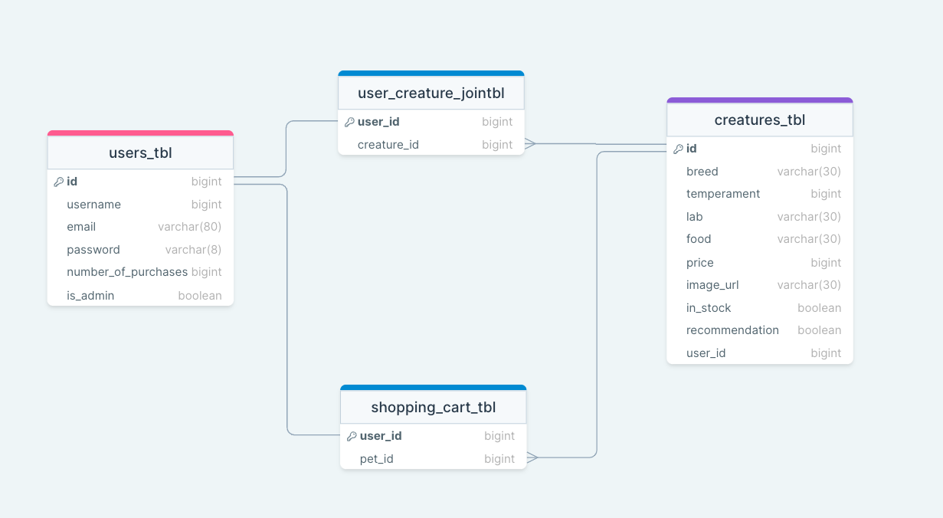

Database name: sol_db

Naming conventions:

No underscores except for the database

camelCase for all variables

Comments at the beginning of functions to describe what the function does

Comments for work-arounds explaining why it was done

